1. Install Power BI Desktop and share the final screenshot of the report view page which appears when power desktop starts.

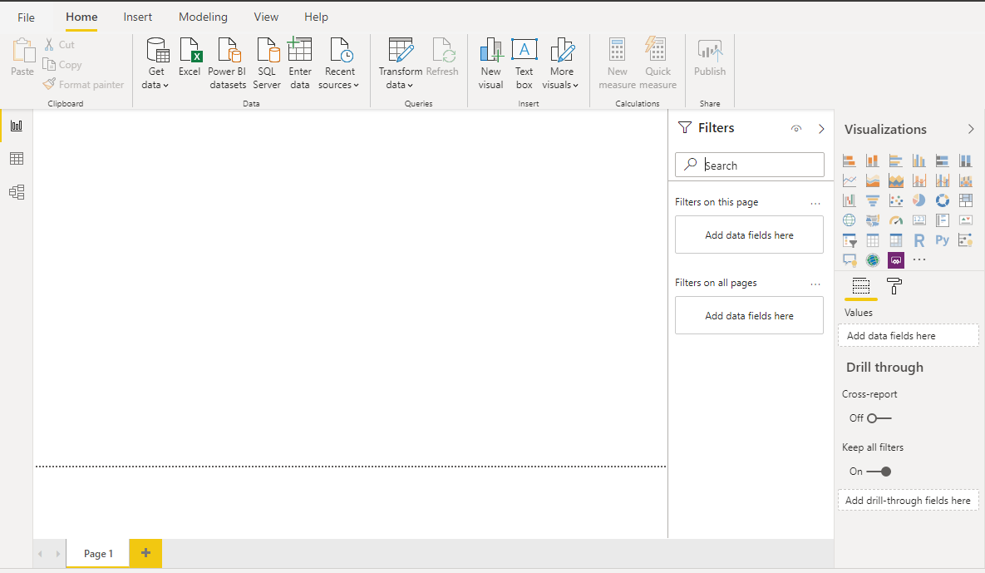

1. Prepare a document and with the following screenshot
   * Report View:
   * Report View is workspace where you can create any number of report pages with visualizations. Report view in Power BI Desktop provides a similar design experience to the report's editing view in the Power BI service. You can move visualizations around, copy and paste, merge, and so on. The difference between them is when using Power BI Desktop, you can work with your queries and model your data to make sure your data supports the best insights in your reports. You can then save your Power BI Desktop file wherever you like, whether it's your local drive or to the cloud.



* + Data View
  + Data view helps you inspect, explore, and understand data in your Power BI Desktop model. It's different from how you view tables, columns, and data in Power Query Editor. With Data view, you're looking at your data after it has been loaded into the model. When you're modeling your data, sometimes you want to see what's actually in a table or column without creating a visual on the report canvas. You might want to see right down to the row level. This ability is especially useful when you're creating measures and calculated columns, or you need to identify a data type or data category.

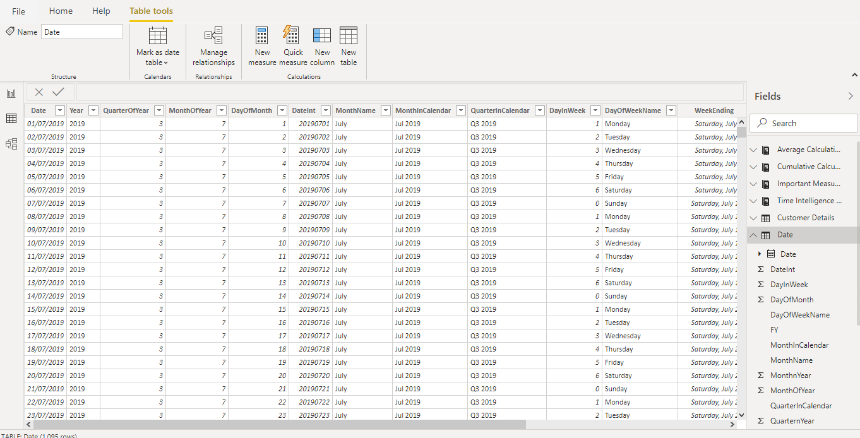

* + Model View
    1. Break out complex models by subject area into separate diagrams.
    2. Multiselect objects and set common properties in one go.
    3. View and modify properties in the properties pane.
    4. Set display folders for simplified consumption of complex models.

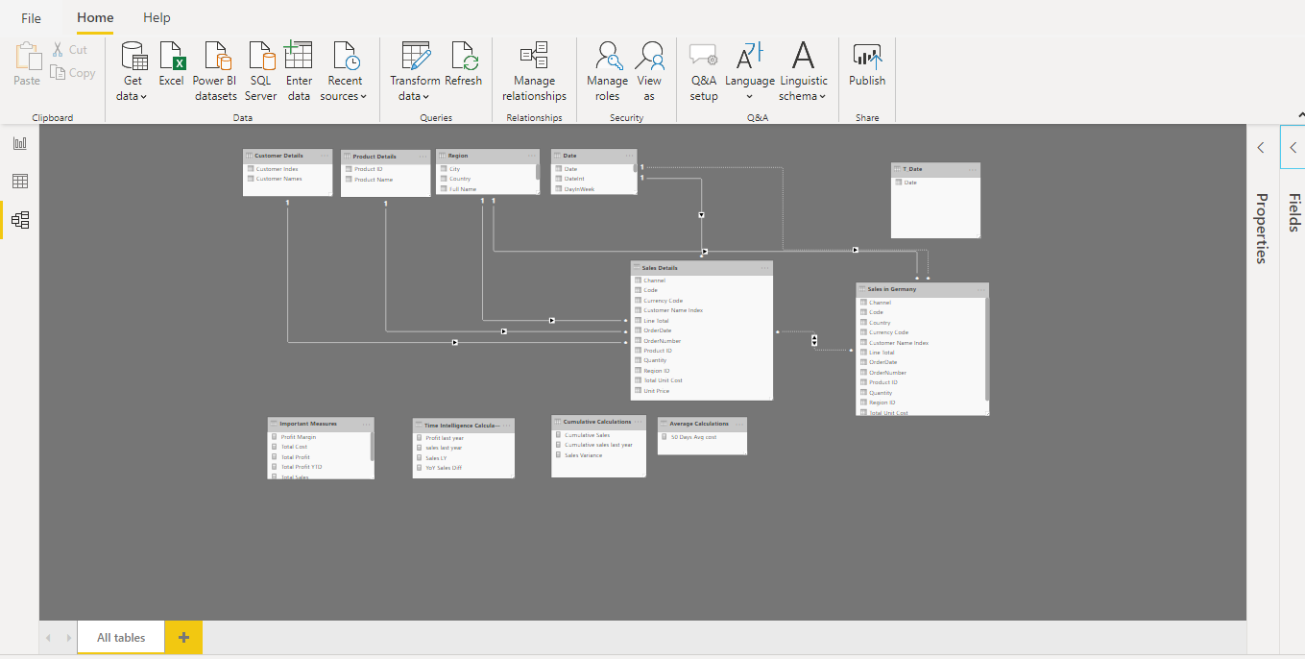

* + Power Query Editor

Power Query is the Data Connectivity and Data Preparation technology that enables end users to seamlessly import and reshape data from within a wide range of Microsoft products, including Excel, Power BI, Analysis Services, Common Data Services for Apps & Analytics, and more.

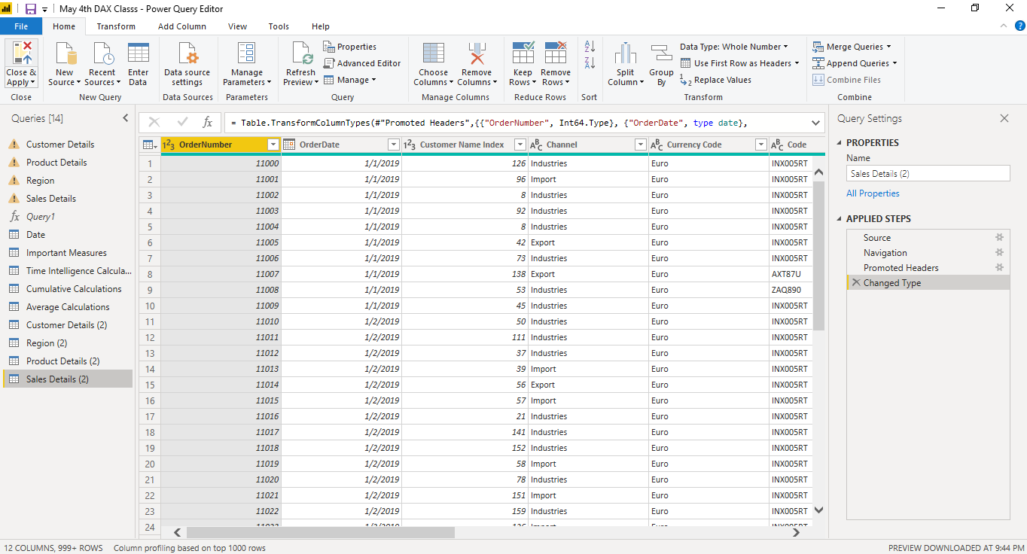

* + Advance Editor

In Power BI Desktop, the M code for each query can be accessed from the Advanced Editor window within the Power Query Editor. With the Power Query Editor open, select a query of interest from the list of queries on the left and click on the Advanced Editor icon from the Home tab to access the following window:

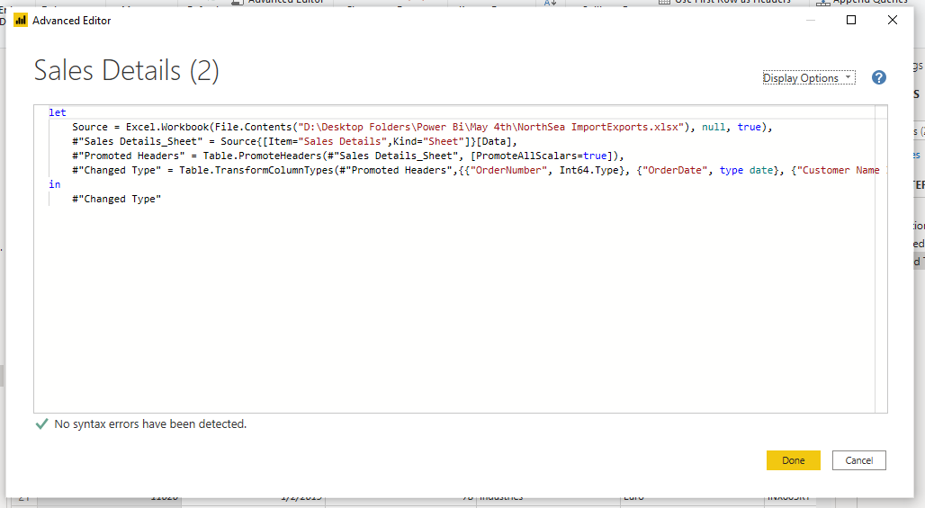

1. Prepare a document with details of the following along with their price
   * Power BI Desktop
     1. Power BI Desktop is the **free version** of Power BI that you can install on your local computer as a program, and acts as a companion desktop application to the full version of Power BI. If you need to consolidate your data sources, create your own reports and conduct your own analysis or test it’s capabilities, it’s the perfect version to start with for all skill levels - whether you’re non-IT and want to make your reports more interactive, or analysts seeking richer detail, it's one of the best business analytics tools to use.
     2. Despite its free nature, you may be surprised at what Microsoft has included with Power BI Desktop:
     3. You can connect and import data from over 70 cloud-based and on-premises sources
     4. The same rich visualisations and filters from Power BI Pro
     5. Auto-detect that finds and creates data relationships between tables and formats
     6. Export your reports to CSV, Microsoft Excel, Microsoft PowerPoint and PDF
     7. Python support
     8. Save, upload and publish your reports to the Web and the full Power BI service
     9. Storage limit of 10 GB per user
   * Power BI Pro
     1. Power BI Pro is the full version of Power BI, complete with the ability to use Power BI for both building dashboards and reports and unlimited viewing, sharing and consumption of your created reports (and reports shared by others) - the latter not possible with Power BI Desktop.
     2. A breakdown of Power BI Pro’s differences against Power BI Desktop:
     3. Ability to embed Power BI visuals into apps (PowerApps, SharePoint, Teams, etc)
     4. Native integration with other Microsoft solutions (Azure Data Services)
     5. Share datasets, dashboards and reports with other Power BI Pro users
     6. Can create App Workspaces and peer-to-peer sharing

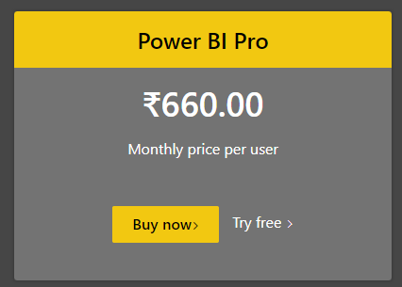

* + Power BI Premium:
    1. Power BI Premium is the most expensive tier of Power BI currently available and very distinct from the other two versions available on the market.
    2. On top of the features and functionality standard to all versions of the service, users of Power BI Premium get:
    3. Increased data capacity limits and maximum performance
    4. Access to one API surface
    5. Ability to embed Power BI visuals into apps (PowerApps, SharePoint, Teams, etc)
    6. Larger storage sizes for extended deployments
    7. Geo distribution, higher refresh rates, isolation, pin to memory, read-only replicas
    8. Power BI Report Server

